CSA1708-ARTIFICIAL INTELLIGENCE
LAB EXPERIMENTS
Program 10 : Python Program to Implement A* Algorithm
Aim
To find the least-cost path from a start node to a goal node using the A* search algorithm.
Algorithm
1. Create a weighted graph and a heuristic value for each node.
2. Add the start node to a priority queue.
3. Select the node with the lowest estimated total cost, f(n) = g(n) + h(n).
4. Update the cost and parent of each neighbor when a cheaper path is found.
5. Continue until the goal is reached, then display the path and its cost.
Program
import heapq

# Graph: neighbor and travel cost
graph = {
"A": {"B": 1, "C": 4},
"B": {"A": 1, "C": 2, "D": 5},
"C": {"A": 4, "B": 2, "D": 1},
"D": {"B": 5, "C": 1}
}

# Estimated distance from each node to the goal
heuristic = {"A": 4, "B": 3, "C": 1, "D": 0}
start, goal = "A", "D"

open_list = [(heuristic[start], 0, start)]
cost = {start: 0}
parent = {start: None}

while open_list:
estimate, current_cost, node = heapq.heappop(open_list)

if current_cost != cost[node]:
continue
if node == goal:
break

for neighbor, distance in graph[node].items():
new_cost = current_cost + distance
if new_cost < cost.get(neighbor, float("inf")):
cost[neighbor] = new_cost
parent[neighbor] = node
total = new_cost + heuristic[neighbor]
heapq.heappush(open_list, (total, new_cost, neighbor))

if goal in parent:
path = []
node = goal
while node is not None:
path.append(node)
node = parent[node]
path.reverse()
print("Path:", " -> ".join(path))
print("Cost:", cost[goal])
else:
print("No path found.")
Sample Input
Start node: A Goal node: D
Program Execution
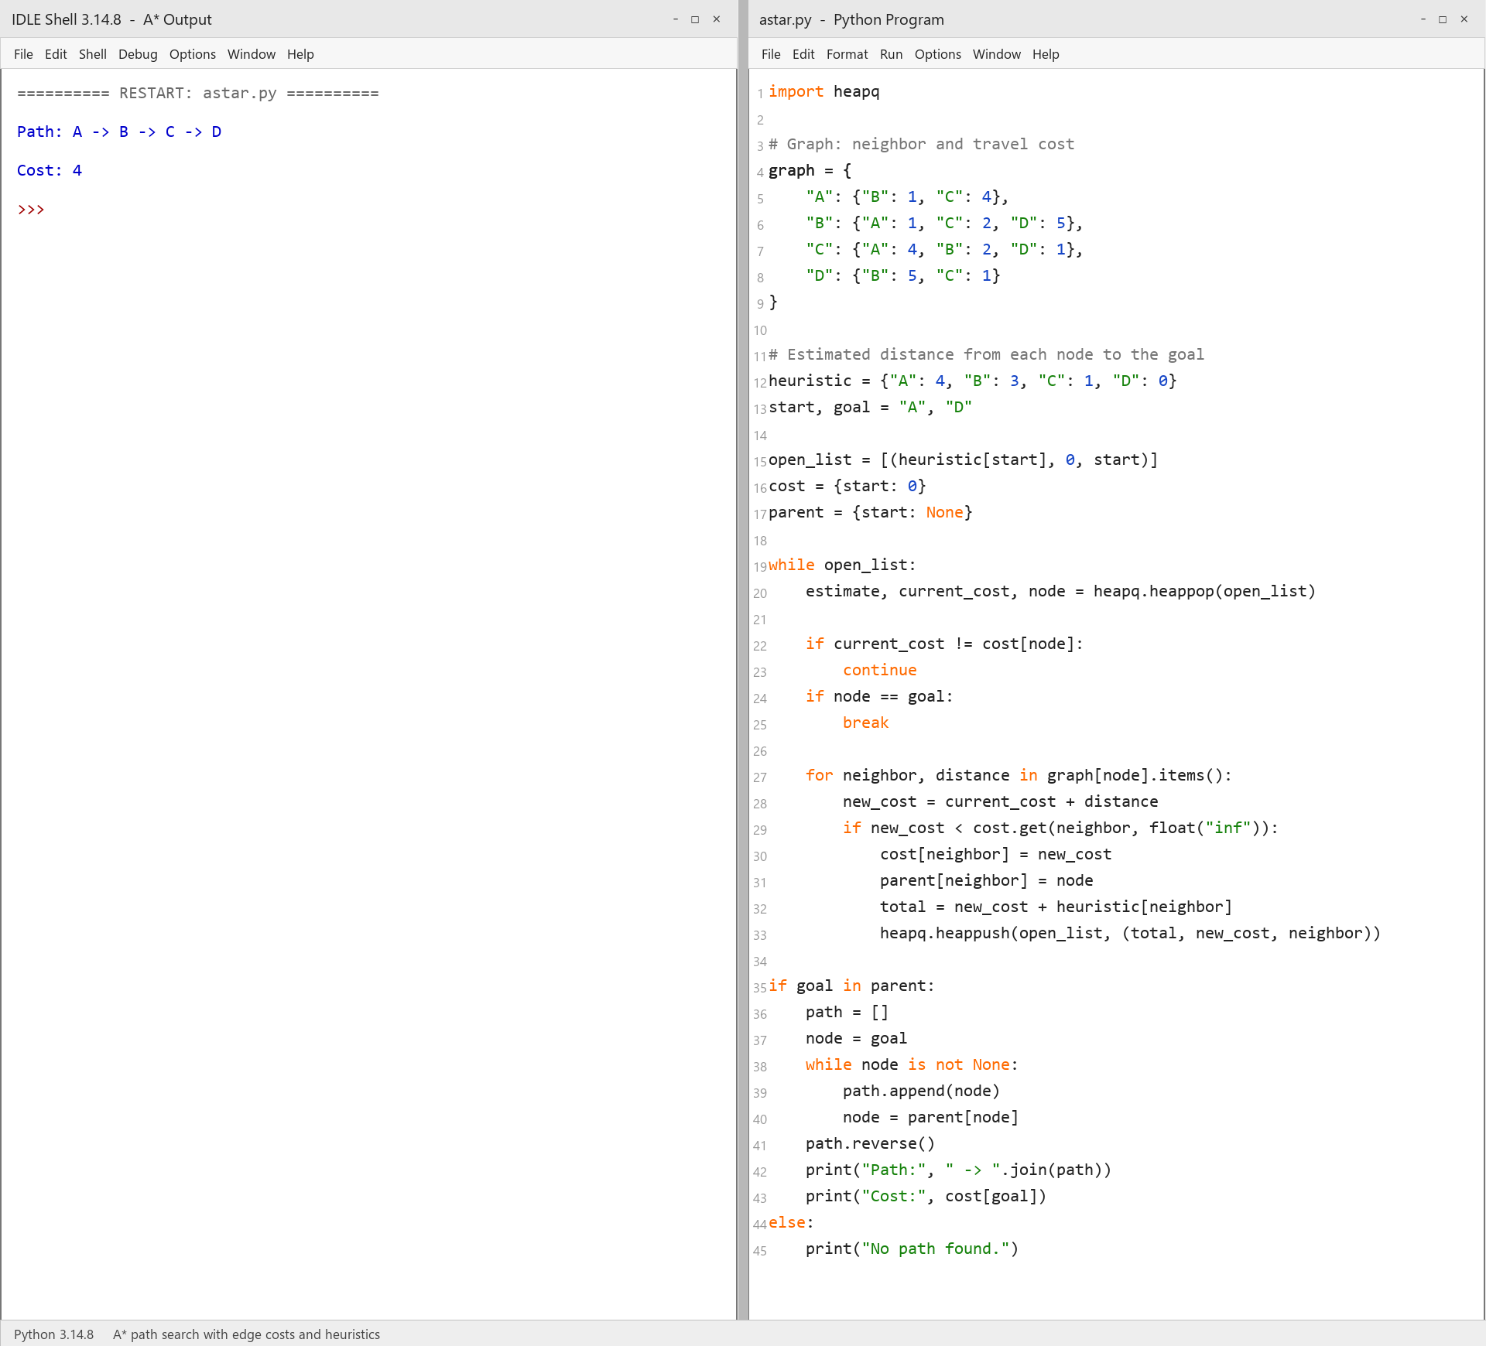
RESULT
Thus, the A* algorithm was implemented successfully using Python.

